**DAY 7 - LIVE DEPLOYMENT AND POST-LAUNCH PRACTICES**

1. **Production Deployment**

* Environment Setup: Added Enviorment Variables.

1. **Secure Hosting:**

* Enable HTTPS for all traffic using SSL certificates: .SSL AND HTTPS enabled.

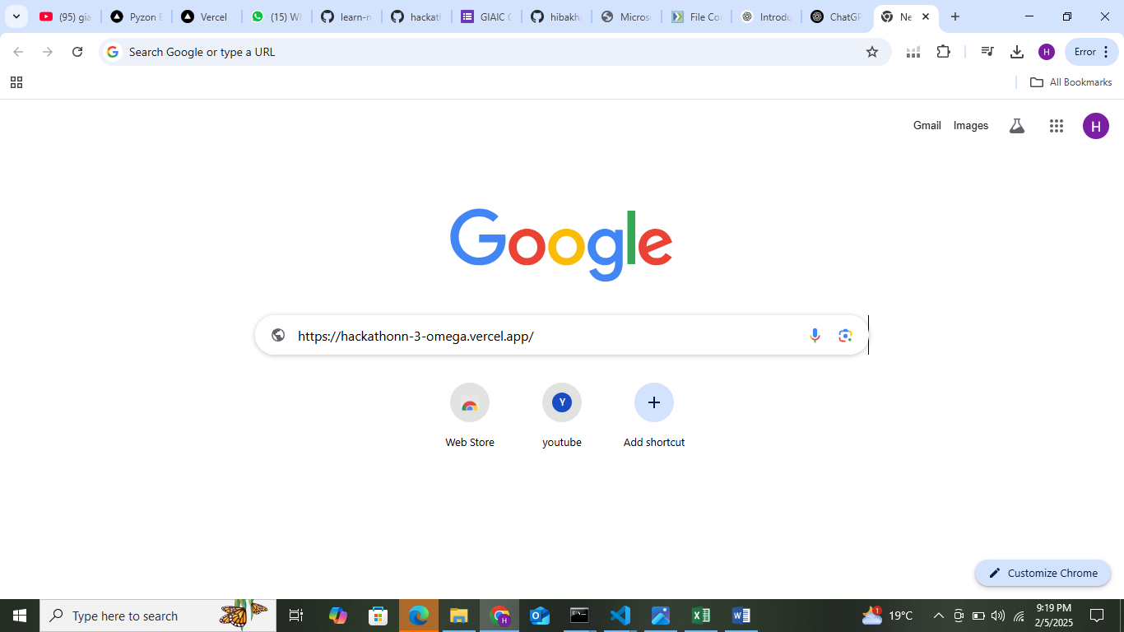

1. **Performance Optimization:**

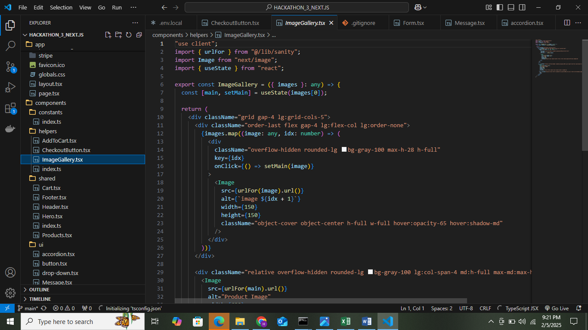

1. **ANALYTICAL TOOLS:**

